Shape Up! 4 Format the home page

In this exercise, you’ll create an external style sheet that you can use to format the Shape Up! home page that you created in module 3. When you’re through, the page should look similar to this:

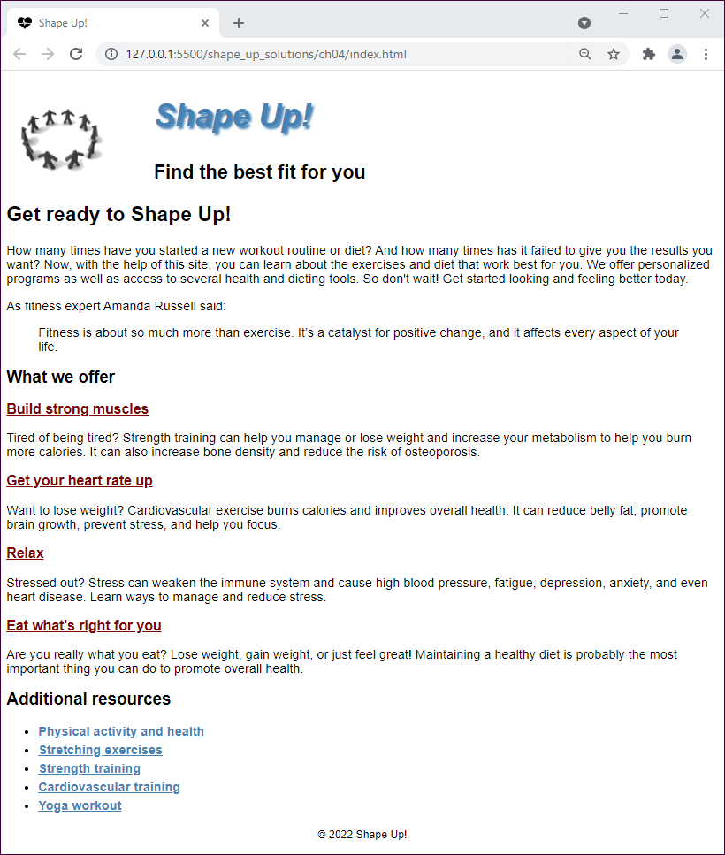

Specifications

* Create the external style sheet for the home page from the main.css file that’s in the styles folder. This file is currently blank.
* Set the default font for the document to a sans-serif font.
* Adjust the font sizes for all of the headings so they look as shown above.
* Format the links in the section so they’re displayed in maroon whether or not they’ve been visited. If a link has the focus or the mouse is hovering over it, though, it should be displayed in steelblue.
* Format the links in the aside so they’re displayed in boldfaced steelblue whether or not they’ve been visited. If a link has the focus or the mouse is hovering over it, though, it should be displayed in maroon.
* In the header, float the image to the left and indent both headings. In addition, change the color of the first heading to steelblue, italicize it, and add a steelblue shadow.
* Format the list to increase the space between the list items.
* Reduce the font size for the footer and center it.
* Link the main style sheet that you just created to the home page.